**Website Information**

**Name:** PokeMart

**Description:** Welcome to PokeMart, buy, sell, and browse for your favourite pokemon cards here!

**Pages:**

1. **Home**

-Contains website name, slogan, and brief description

-featured card list with hero elements displaying the image, brief description, and title

-navbar for quick links to card list, about, contact, sign in/out, and searchbar

1. **Card List**

-Contains search filter element

-list of cards

-pagination feature

1. **About us**

-Static navbar

-Image with description of our website

1. **Card Detail page**

-Upon click from card list displays full details of the card

-Add to favourites button to add product to users favourite list

-similar products according to the card chosen

1. **Favourites List**

-Loads user’s favourite list of cards they have “favourited”

1. **Contact Us**

-“Contact Us” form to fill out a the user’s personal details and message they want to send

1. **Join Us**

-Register a new user to the site

-Form field with email, password, confirm password, and register button

1. **Sign in**

-Similar to register but with email and password to validate and authenticate user

**Sample Products:**

Single Cards:

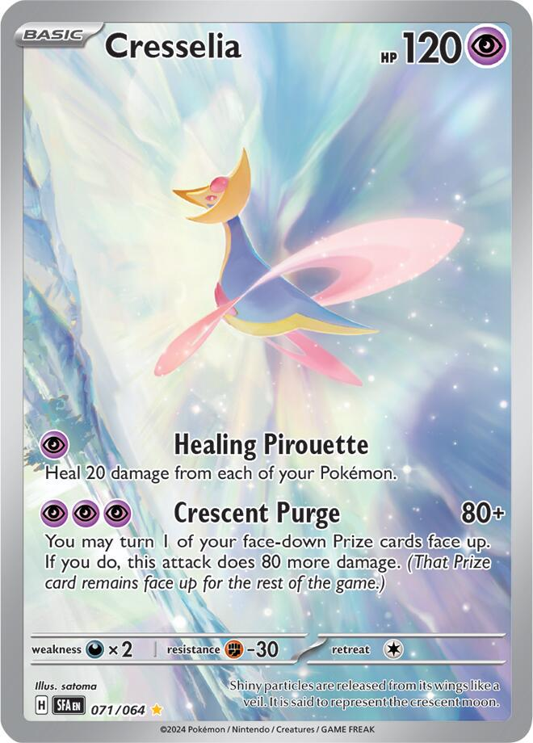

Our Product detail could have a price chart and card details shown according to the json dataset.

Booster Packs:

Similar to our single cards our different types of booster packs will have the same information but no price chart changes and will have a static set price.

Booster Boxes:

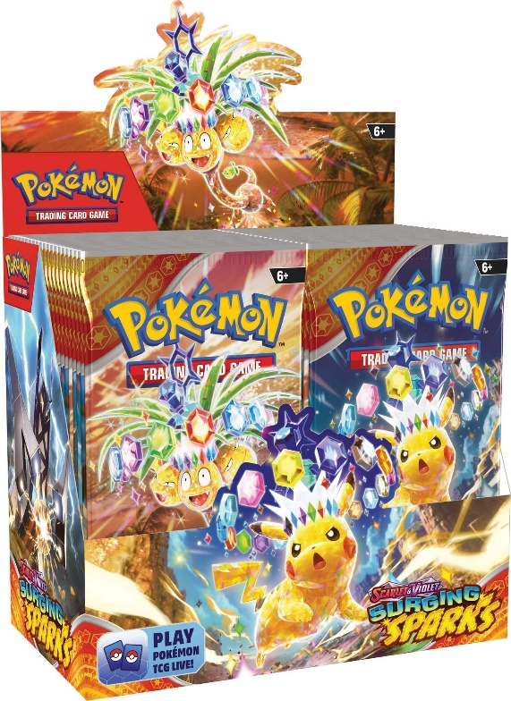

The booster box is a larger version of the booster pack and will hold the same information as the pack variety.

Discontinued Products:

For example here we could use niche products and label them as discontinued or out of stock, an example here is the vivid voltage Charizard theme deck.

